DAILY TIMETABLE
Thursday 11th June 2020

Breakfast
Prepare yourself for the day ahead.

Daily Check In/Register
Go into Classwork/Register and cross Thursday to show us you are “in school”. If you find it difficult to access this, please leave a comment and that way we know you’re here!


P.E.
Join Joe Wicks for today’s PE lesson. Do it live at 9.00am or later.
Take a short break if you find it hard, then join in again. Remember exercise releases chemicals in your brain that make you feel better.
https://www.youtube.com/watch?v=png9xGaRvGE
Numeracy - Division

First watch a short reminder about division https://www.youtube.com/watch?v=bdglIPNNhuI

Next for some practice go to SUMDOG
Go to TASKS and choose division tables.
Try and gain your bonus coins for completing 20 minutes.

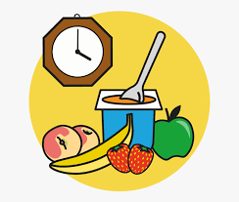
Snack Time
Feed your body and your brain. 😊
Literacy
A fairy tale retold is waiting for you in the literacy section. Complete the questions at the end.

For relaxation you could listen to more episodes of James and The Giant Peach
https://www.youtube.com/results?search_query=roald+dahl+hq

Lunch
It’s time to take a break and recharge your body.

Health and Wellbeing If you haven’t watched the NSPCC assembly with Ant and Dec do it now https://www.youtube.com/watch?v=qm0kccbZpYY
Finally have some fun and choose another activity from the challenge on the school blog

If you can’t access the classroom email me
ann.martin@invergordonacademy.org.uk

