DAILY TIMETABLE
Wednesday 10th June 2020

Breakfast
Prepare yourself for the day ahead.

Daily Check In/Register
Go into Classwork/Register and cross Wednesday to shows us you are “in school”. If you find it difficult to access this, please leave a comment and that way we know you’re here!


P.E.

“Wake Up and Shake" with Amy Gallagher...

@ 9.30am

The fabulous Amy Gallagher from Highlife Highland will be streaming LIVE across Highland Homes to ANY children who wish to 'get their groove on'! The live stream will take place every Wednesday at 9.30am and all you have to do to join in, is click on the link below, just before the session begins.

https://stream.meet.google.com/stream/f0b34fdd-6350-403e-8e76-e5f29856ce63

Please note: this stream will only work if pupils are signed into their highland google account.

NSPCC Assembly
Welcome to the NSPCC virtual ‘Speak out. Stay Safe.’ assembly! This session will be led by the wonderful Sally from NSPCC’s Schools Service, and features special guest appearances from Ant and Dec, David Walliams & Children and Families Minister Vicky Ford MP. https://www.youtube.com/watch?v=qm0kccbZpYY

Watch carefully and be prepared to answer some questions!

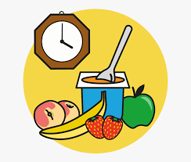
Snack Time
Feed your body and your brain.
Spelling
The sound ‘ow’ like in ‘cow’. Let’s grow some words. Use your words or some of the ideas below:
- mount
- out
- crowd
- down
Remember: if you can’t access Google Classroom, you can email your work to me ana.candidobarton@invergordonacademy.org.uk

Reading
This is the last chapter of our class novel Crash Landing: Hyperspace High (Book 1),
by Zac Harrison.
https://stories.audible.com/pdp/B00FL4S5FC?ref=adbl_ent_anon_ds_pdp_pc_pg-1-cntr-0-24

Synopsis
When John Riley gets on the wrong coach, he ends up at an elite academy on an enormous spaceship, where his classmates are aliens, the food is disgusting, and the penalty for failing exams is harsh. Can he show that he deserves a place at Hyperspace High?

Listen to Chapter 16

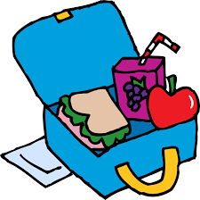
Lunch
It’s time to take a break and build up your energy.

Writing
Now that you have listened to our class novel in full, you are going to write a book review. Go to Classwork/Literacy and open Book Review Template to help you to structure your review. Make sure that you include all the sections which can be used as headers.

Please create a Google doc and share it with ana.candidobarton@invergordonacademy.org.uk or, if you can’t access Google Classroom, email your work to the same address

Health & Wellbeing
Look at the Health and Wellbeing Challenges for this week on the school’s blog. Each member of the staff has picked a daily challenge for you and you get to see us doing it too! Choose one challenge for each day of the week and give it your best try; we will all be doing the same!
Remember: our health and wellbeing target in June is to walk, run or cycle 5 Km each week; don’t forget to post photos of you doing it, to go on the school’s blog!

