DAILY TIMETABLE
Wednesday 3rd June 2020

Breakfast
Prepare yourself for the day ahead.

Daily Check In/Register
Go into Classwork/Register and cross Wednesday to shows us you are “in school”. If you find it difficult to access this, please leave a comment and that way we know you’re here!


P.E.

“Wake Up and Shake" with Amy Gallagher...

@ 9.30am

The fabulous Amy Gallagher from Highlife Highland will be streaming LIVE across Highland Homes to ANY children who wish to 'get their groove on'! The live stream will take place every Wednesday at 9.30am and all you have to do to join in, is click on the link below, just before the session begins.

https://stream.meet.google.com/stream/f0b34fdd-6350-403e-8e76-e5f29856ce63

Please note: this stream will only work if pupils are signed into their highland google account.

Writing
This week we are again looking for bloggers! John and Noah did a fantastic job last week, we look forward to seeing some of your work too. Write about your weekend in the sun (what you have done, where did you do it, who were you with, etc.) and send your posts of photos to me so that I can compile them and post them on the P4/5 school blog.

Remember: if you aren’t using Google Classroom, you can email your work to me ana.candidobarton@invergordonacademy.org.uk

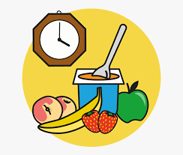
Snack Time
Feed your body and your brain.
Art
Origami is the art of folding paper to create different shapes, like animals or flowers. Some believe it originated in Japan, many centuries back, but others argue it might have appeared in China first. Regardless, origami is both entertaining and relaxing, and it really only requires paper! (you can choose to use pens or other craft materials to decorate it, but it is not essential)

Follow one of the links below or look at the folding instructions in Classwork/Art/Origami to create an origami animal.
Butterfly: https://www.youtube.com/watch?v=cZdO2e8K29o
Turtle: https://www.youtube.com/watch?v=JlJsU8tspfc
Frog: https://www.youtube.com/watch?v=ChrVW4ruOPQ
Dinosaur: https://www.youtube.com/watch?v=lKOVYw9R7oI
Health & Wellbeing
Look at the Health and Wellbeing Challenges for this week on the school’s blog. Each member of the staff has picked a daily challenge for you and you get to see us doing it Choose one challenge for each day of the week and give it your best try; we will all be doing the same!

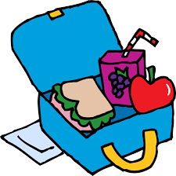
Lunch
It’s time to take a break and build up your energy.

Reading
Our class novel is the audio book: Crash Landing: Hyperspace High (Book 1),
by Zac Harrison.
https://stories.audible.com/pdp/B00FL4S5FC?ref=adbl_ent_anon_ds_pdp_pc_pg-1-cntr-0-24

Synopsis
When John Riley gets on the wrong coach, he ends up at an elite academy on an enormous spaceship, where his classmates are aliens, the food is disgusting, and the penalty for failing exams is harsh. Can he show that he deserves a place at Hyperspace High?

Listen carefully to Chapters 11 to 13 and spot words with the sound ‘ai’, like in ‘rain’. Write down as many as you can in your spelling Google doc or on a piece of paper (email a photo of your words to ana.candidobarton@invergordonacademy.org.uk )

Spelling
The phoneme ‘ai’ like in ‘rain’. Today’s task is linked to your reading (see above).

